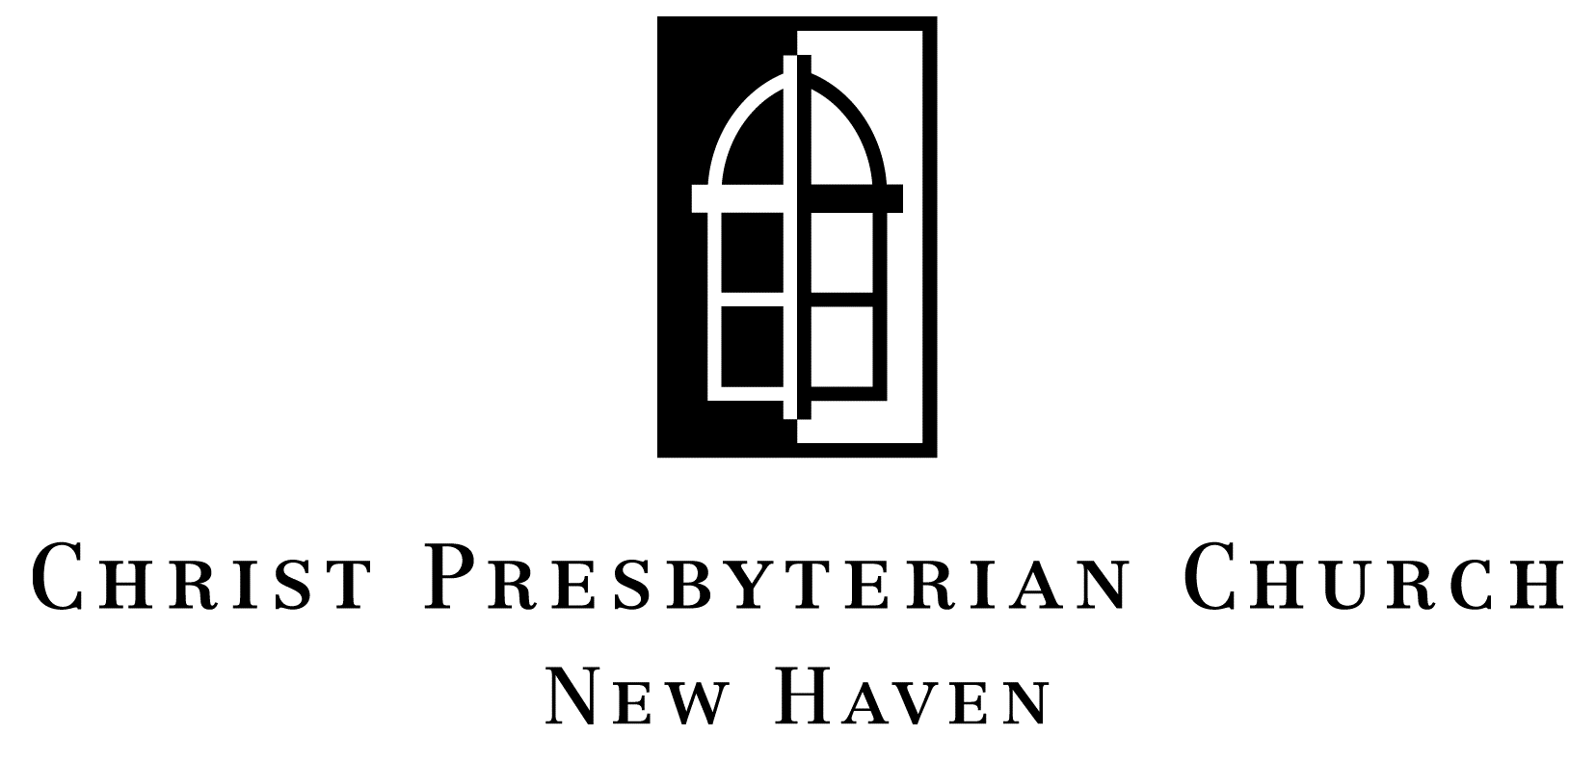

135 Whitney Avenue  New Haven  Connecticut 06510
Phone 203 777 6960  Fax 624 5096  Web christpresnewhaven.org

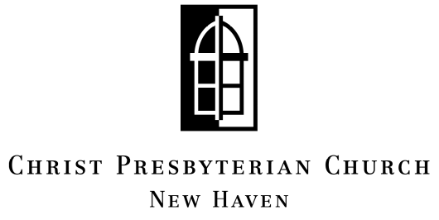

Ministry Connection
2005-2006

“For even the Son of Man did not come to be served, but to serve, and to give his life as a ransom for many.”

Mark 10:45

Name(s):
________________________________________________

Phone __________________________________________

E-mail __________________________________________

My relationship to Christ Presbyterian Church:

If Student:
 Visitor  Undergraduate
 Regular Attender  Graduate
 Member

Opportunities for Service:

I am willing to consider serving the church in the following way(s):

Sunday Morning Ministry Needs:
- Coffee maker
- Ushers/Greeters (6-8)
- Person to lock up building after worship
- Sound technicians (sermon recording, duplication) (2)
- Pianists (3)
- Infant/Toddler Caretakers (8-10)
- Sunday School Teachers (7)

Wednesday Night Ministry Needs:
- Set-up Workers (4)
- Clean-up Workers (4)
- Infant/Toddler Caretakers (2)
- Kids’ Club Leaders (3-4)

Flexible Schedule Ministry Needs:
- Bulletin Folder (Friday or Saturday)
- Facility Cleaners (8-10)
- Book Balancer/Account Assistant
- Lawnmower
- Church Librarian (no experience necessary)
- Administrative helper (photocopying, net research, etc.)
- Handypersons (2-3)
- Newsletter Coordinator

The bottom line: we need about 70 people to commit to serving in the above listed ministries for our church to run smoothly. Serving is a great way to become more connected to your church, get to know the congregation, and build up the body of Christ. Please prayerfully consider filling one of these very important ministry roles and making it your own!

If you have any questions, see a servant leader. We’d be happy to talk to you about these ministry opportunities or any other questions about life at CPC.

Opportunities for Fellowship and Growth:

I am interested in learning more about:

- CPC Neighborhood Bible Studies – We strongly encourage everyone in the church to participate in a group in order to experience the life of God as expressed more locally & intimately through a small group context. Groups meet every 1st & 3rd week of the month.
- Wednesday Night Fellowship/Bible Study-meet for fellowship over a meal followed by Confessional Theology & Bridging the Ancient and the Present. Every 2nd & 4th Wednesday of the month – 6:00 pm to 7:30 pm.
- Wednesday Night Kids’ Club – meets during the Wednesday night fellowship classes above – enjoying Bible Study, singing, arts & crafts.
- Graduate/Young Professional Fellowship – meets every 1st & 3rd Thursday evenings at 7:00 pm for fellowship, prayer, study & personal encouragement.
- Reformed University Fellowship Campus Ministries – worship, Bible Study, retreats, mercy ministry.
- Sexual Brokenness Seminar – Saturday, October 29th 8:30 am – 4:30 pm. Seeing the relevance of the gospel to our sexual identity.
- Church Wide Retreat – November 11th – 13th. Located in beautiful Exeter, Rhode Island. Guest Speaker is Dr. Gregory Ganssle – Living for the Kingdom.
- Child Discipleship Seminar – a seminar on parenting. March 24th & 25th or April 28th & 29th, 2006 - TBD.
- Southern New England Youth Retreat – March 2006. The group will plan for an exciting weekend at Evangelical Baptist Camp - for fellowship, fun and skiing with other New England PCA church groups.
- Youth Theology Camp - week of June 26, 2006 - for students 8th grade and up. This year the group will visit Princeton Seminary.
- Men’s & Women’s Ministry – meet throughout the year for fellowship. Ladies Night Out is planned for Friday, October 14th. Men’s event is planned for Saturday, January 28, 2006.
- CPC Bowling Outing – Saturday, January 14th
- Arts Show – Friday evening, February 20th
- Mom’s Book Study – meets every Tuesday at CPC, 10:00 – 11:00 am
- Lunchtime Concerts Series – each Wednesday in April 12:15 to 1:00 pm at CPC.

